# BE – How to run ?

* **Step 1**: check out BE source from <https://github.com/saothienhat/Devdirect-BE-TrinhThanhBinh.git>
* **Step 2**: import project to Eclipse
* **Step 3**: run project (run **BeApplication.java** file) using Spring Boot as below snapshot:

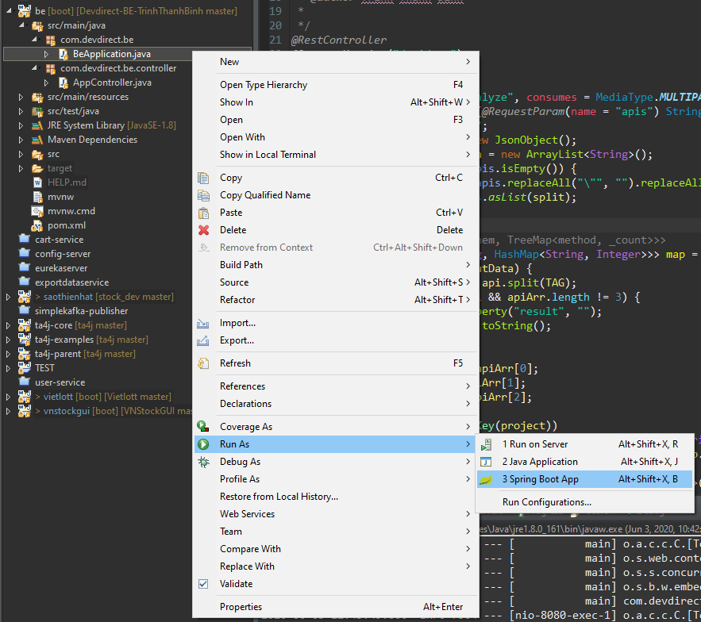

After run file, the server will start on port **8080** (for example)

* **Step 4**: open Postman and setting to call API

API: <http://localhost:8080/api/app/analyze>

Test Data: *["unishop/product/list","unishop/category/list","unishop/product/create","kyowon/user/list","commerce/product/create","kyowon/user/create","kyowon/banner/update","unishop/category/update","commerce/product/create","unishop/product/list","unishop/category/list","commerce/product/update","unishop/product/create","kyowon/user/list","commerce/product/delete","kyowon/user/create","kyowon/banner/update","unishop/category/delete"]*

Please note that setting to run API on Postman (parameter key is ***apis***) as below snapshot:

